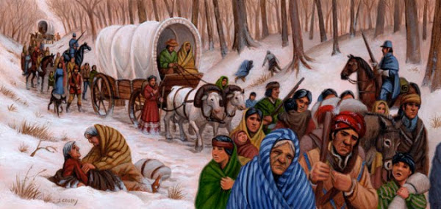
Trail of Fears
When there are no answers, is faith enough?

One of America’s greatest tragedy’s…brought to life.
In 1830, Thomas Grayson, a missionary from Charlotte, North Carolina, has answered the call to preach the Gospel to the Cherokee people. Unbeknownst to him, the United States Congress passed the Indian Removal Act and President Jackson signed it into law.
Caught between resistance from the Cherokee to accept a white man in their midst and the lack of acceptance by his own family, Thomas strives to honor God. A young, beautiful Cherokee maiden, Adsila, who sees him as the source off of her people's problems, fights her feelings which confuse her.
When the Cherokee people defy the government and are forcibly removed, Thomas joins Adsila, her family, and the entire Cherokee nation as they traverse the infamous Trail of Tears from Georgia to west of the Mississippi River. Thomas struggles to find God in the middle of such tragedy, and fails to have the answers for Adsila, who has come to accept Him as well.
Historical Fiction ~ 65,000 Words

SARA R TURNQUIST
“Historical Fiction with meaningful romances…”

Sara lives in middle Tennessee and writes historical fiction. Her debut novel, “The Lady Bornekova” will be released July 2015, through Clean Reads (formerly Astraea Press). Sara is a member of the ACFW.

saraturnquist.com
sarav1701@yahoo.com
Twitter: @sarat1701
Facebook: Sara Vertrees Turnquist
Pinterest: www.pinterest.com/saravturnquist/

